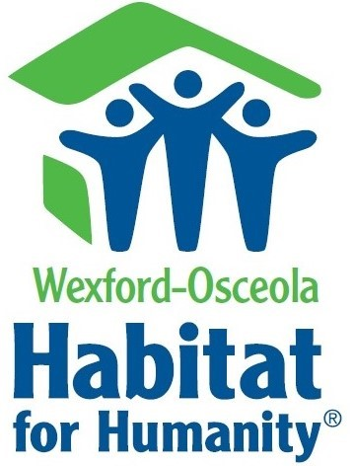

**Contact:**

Amy Gibbs

Wexford Osceola Habitat for Humanity

231-468-1096 director@wexfordhabitat.org

www.wexfordhabitat.org

Bidding Information

An open house is scheduled for Friday, June 4th from 3:00 – 6:00 PM and the home is located at 356 Bacon St in Lake City, MI

Bidding will start on June 5th, 2021 and the details for that are below.

* Bids must be submitted via email to: [director@wexfordhabitat.org](mailto:director@wexfordhabitat.org) by June 18th, 2021.
* Bid starts at $100,000. A letter of verification from a financial institution to show sufficient deposit on hand to cover the purchase is required with bid.
* Buyer is responsible for costs associated with the move from Bacon St in Lake City to final destination.
  + Rollaway Movers has agreed to move the house within a 15-mile radius of the current location at an expense of $5,000 above the winning bid. Longer move can be discussed directly with mover, any additional costs are the buyer’s responsibility.
  + Fees associated with utility companies will be at the buyer’s expense.

(ie. Consumers Energy, Spectrum)

* + - **Consumers Energy Route Plan could take up to 6-8 months. **
* Winning bid requires a 50% non-refundable deposit via bank cashier’s check or wire transfer, must be received within 5 days of winning bid notification. Remainder due prior to move of home.
* If house is not moved by December 31st, 2021 there will be an additional $1,000 fee per month for storage.
* House must be moved by May 1st, 2022.

All proceeds will go towards providing safe and affordable housing for residents in Wexford and Osceola Counties.

Please call 231-468-1096 or email Amy at director@wexfordhabitat.org with any questions or to request additional information.

**About Habitat for Humanity:**

Habitat for Humanity is a nonprofit a Christian based organization seeking to put God’s love into action and bring people together to build homes, communities, and hope.